**HSS ASSIGNMENT-TREE PLANTATION**

**TREES PLANTED: -**

1. Arabian Jasmine (MOGRA)
2. Chrysanthemums (SHEVANTI)
3. Curry Leaves (KADIPATTA)

**TYPE OF SOIL USED**- RED SOIL

**FERTILIZER-** HOMEMADE VERMICOMPOST(GANDULKHAT)

**CURRENT STATUS: -**

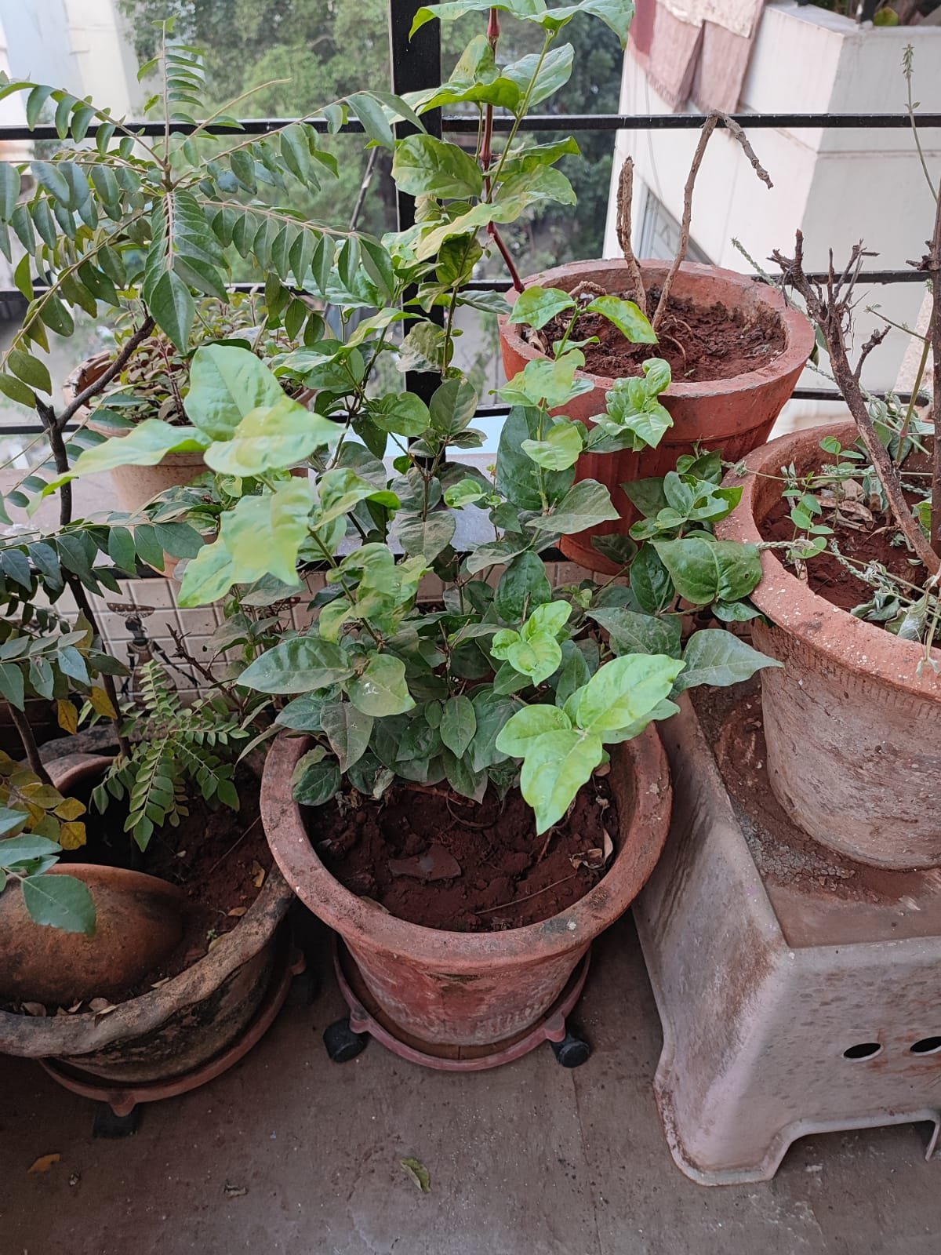

**1.MOGRA**

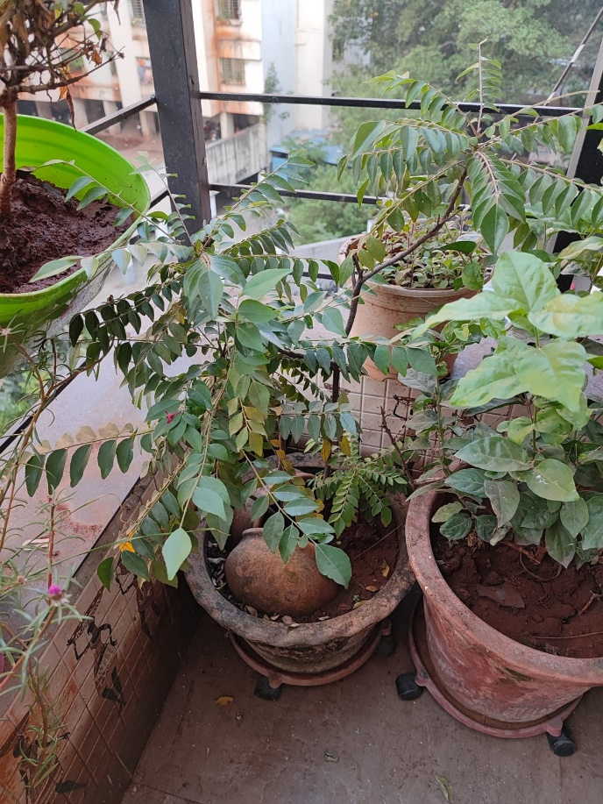

**2. CURRY LEAVES(KADIPATTA)**

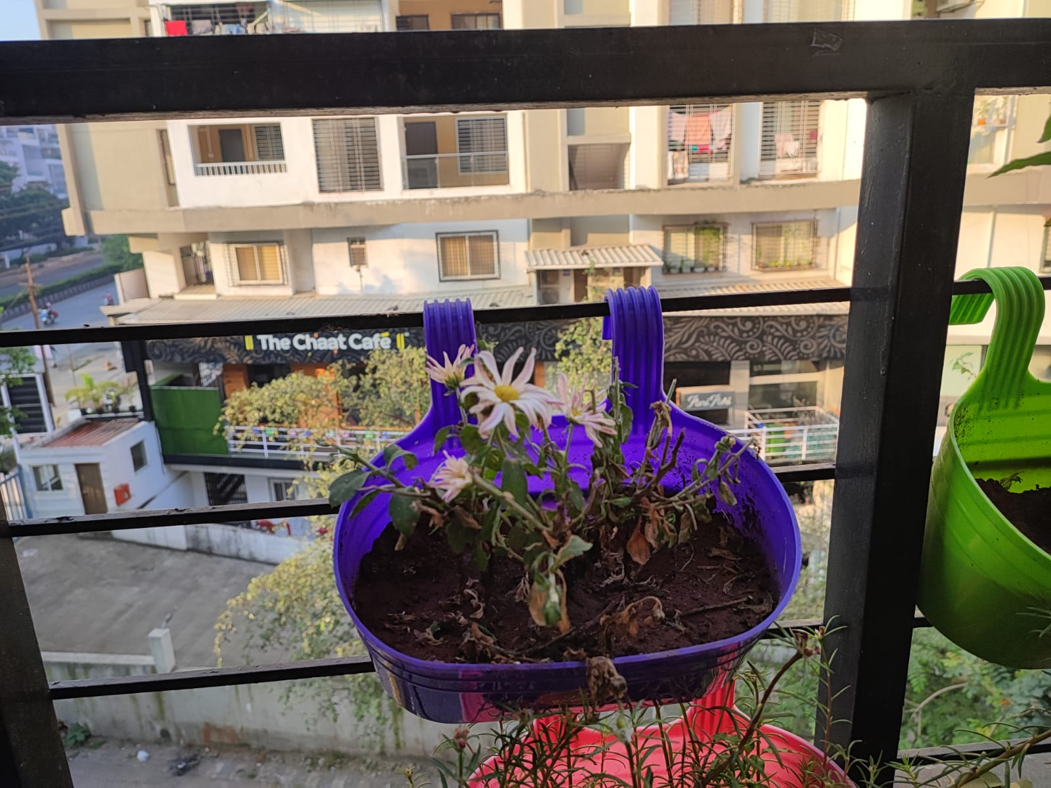

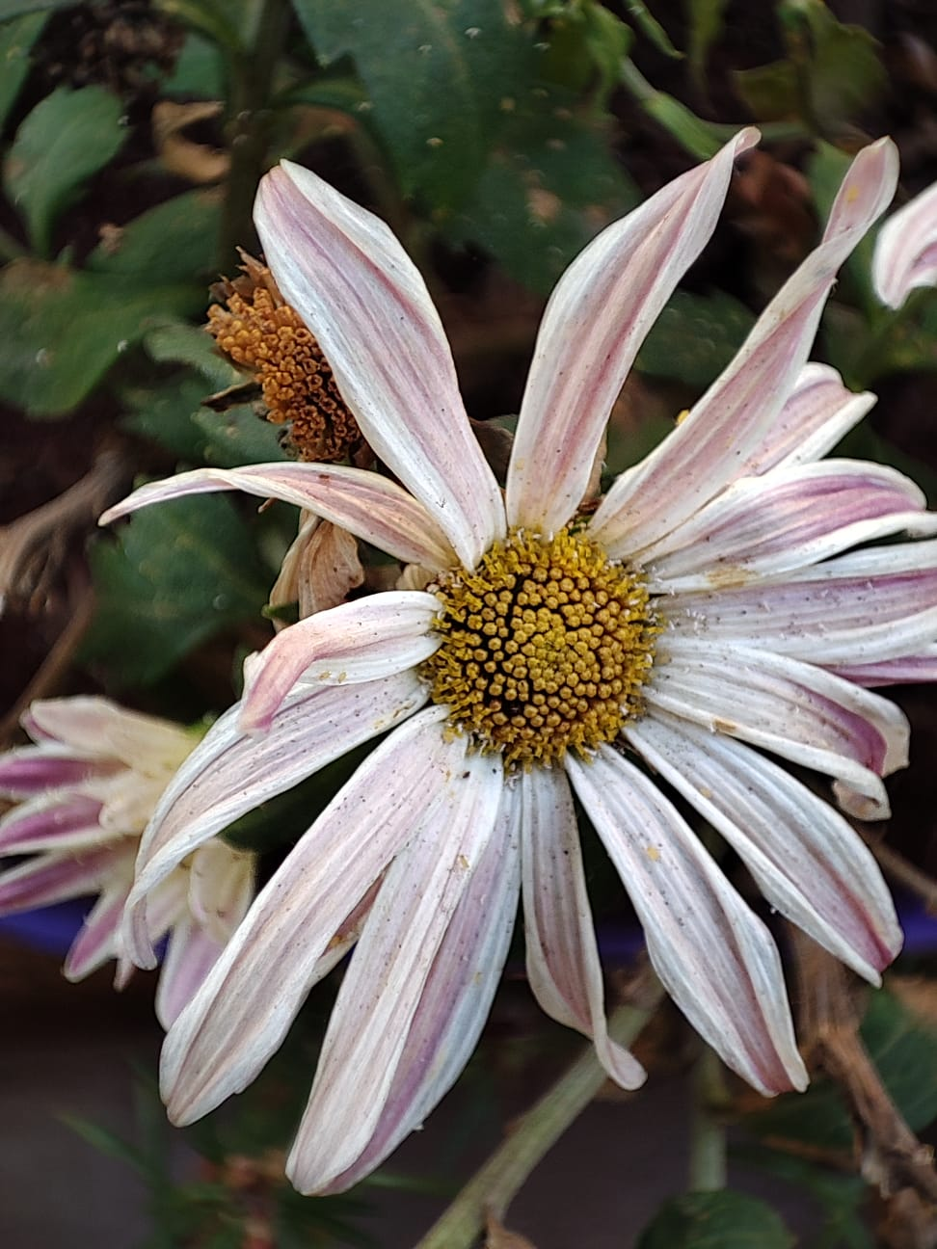

**3. Chrysanthemums (SHEVANTI)-WHITE**

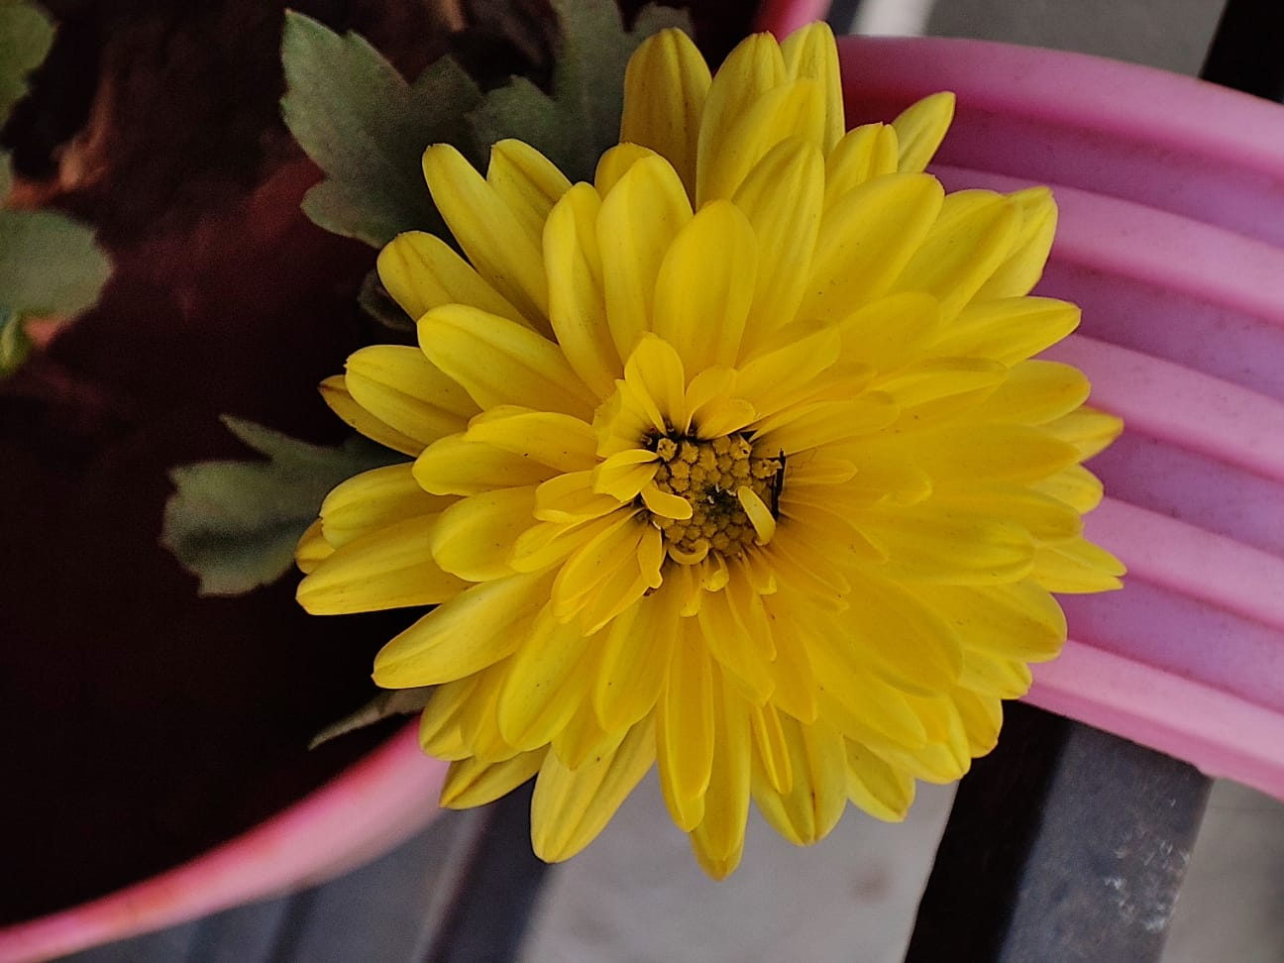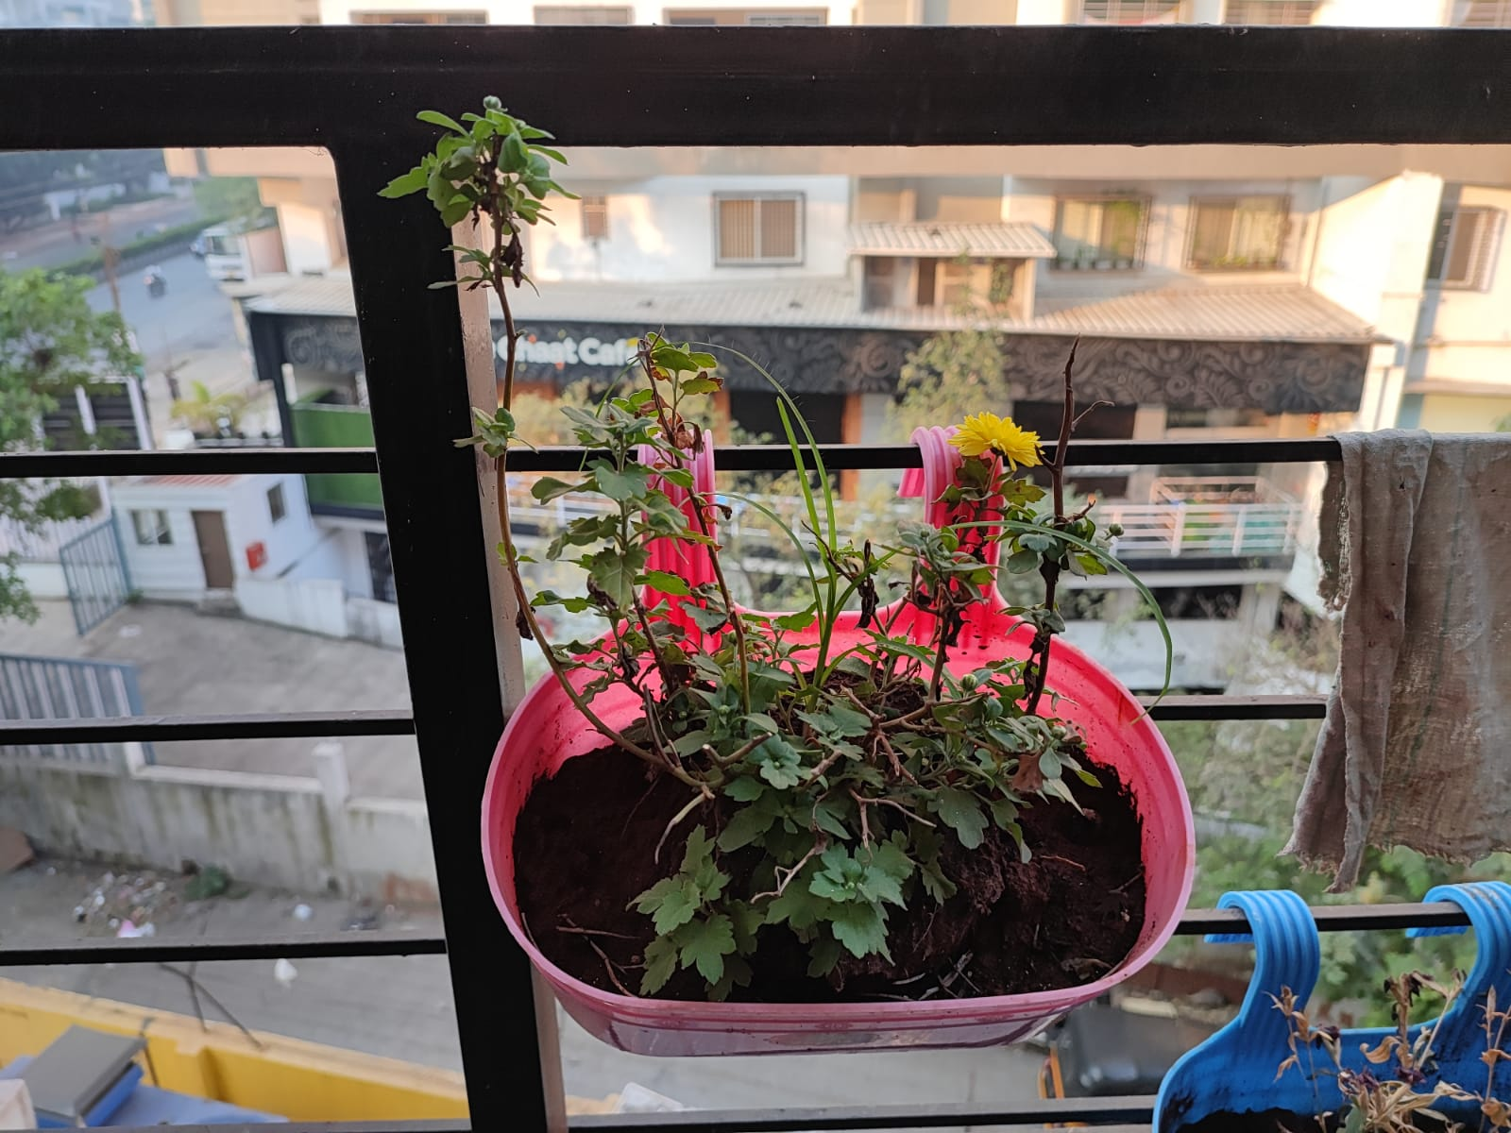

**4.Chrysanthemums (SHEVANTI)-YELLOW**